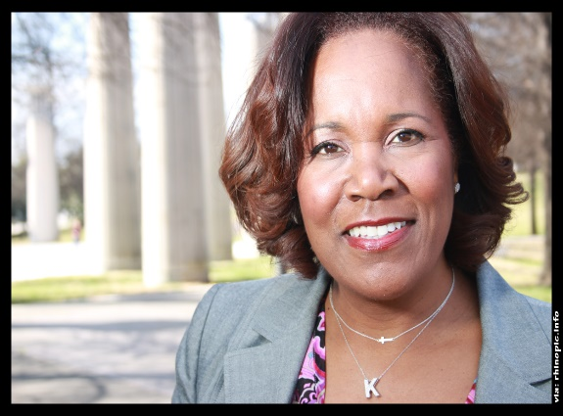

Kerry Schrader, Cofounder/CEO, holds a BBA, MBA and has held both the SPHR and SHRM-SCP designations. Kerry has more than 25 years’ experience positively impacting the human assets of large companies including Ford, Alcoa, and Sears Holdings Corporation.

Mrs. Schrader has vast experience developing programs that engage workforces with results that increase productivity and bottom-line profitability. Residing in Franklin, a suburb of Nashville, TN, Kerry is a member of Delta Sigma Theta Sorority, the Nashville Entrepreneur Center and Black in Tech-Nashville; serves as the Corporate Treasurer for a Nashville-based investment group, has volunteered for local charities including Big Brother Big Sisters of Williamson County, Girls, Inc . and Girls To The Moon.

Most recently, she has been appointed to The Nashville Technology Council's Executive Board of Directors; chairing the Diversity Committee.

